Solution walkthough

P001 - University Research Performance

Table of Contents

P001 - University Research Performance
Project Overview
Business Context
Data Cleaning Steps
Logical Data Modeling
Galaxy Schema Approach
Fact Tables
Dimension Tables
Fact Table and Dimension Design
Fact Table: Fact_Projects
Fact Table: Fact_Patents
Dimension Tables and Rationale
Dim_Researches
Dim_Projects_Detail
Dim_Patents_details
Dim_Publications
Data Model (ER diagram):
Physical Data Implementation
Create table queries:
Populate Table queries:
Deliverables

Project Overview
In this project, I designed and implemented a complete end-to-end BI solution from university research data. The project covered the full analytics development lifecycle—from requirements understanding and gathering to data cleaning, data modeling, transformation logic, the creation of an analytics-ready schema, and developing Tableau dashboard. Using the provided datasets on research projects, staff profiles, patents, and publications, I built a dimensional model that supports cross-domain insights and enables centralized reporting across all research activities.

Business Context
The Research Project Office oversees multiple parallel research activities, including project funding, researcher involvement, publication output, and patent commercialization. These datasets were originally siloed across different sources, making it difficult to produce consolidated insights or evaluate performance. The objective was to design a scalable analytics model that connects these domains using consistent keys and clean, standardized data. The outcome enables leadership to monitor project performance, funding utilization, researcher productivity, and research impact in a single analytical ecosystem.

Data Cleaning Steps
1. Renamed Key Columns
To maintain consistency across all tables, key fields were standardized.
- Author → Staff_ID
- Inventors → Staff_ID
2. Transformed the Inventors Column into a Usable Key Format
The original Inventors field contained multiple staff identifiers in a comma-separated list.
To normalize this into one row per inventor, the following logic was applied:
SELECT
p.Patent_ID,
LTRIM(RTRIM(s.value)) AS Researcher
FROM Patents p
CROSS APPLY STRING_SPLIT(p.Inventors, ',') s;

This produced a clean, relational structure suitable for building a bridge/fact table.
3. Divided Patents table to fact table and dimensional table

4. Ensured Consistent Data Types
All fields were validated to ensure correct and consistent data types across tables, including:
- Numeric fields (ImpactFactor, Citations, RevenueCorrect)
- Date fields (FiledYear, StartDate, HireDate)
- Boolean fields (IsCommercialized)
- Text fields cleaned for whitespace and formatting issues

Logical Data Modeling

Galaxy Schema Approach
To ensure a clean, normalized, and analytics-friendly model, I designed the research data warehouse using a galaxy schema because it consists of 2 fact tables and business processes. This structure supports high-performance querying, simplifies reporting logic, and keeps all subject areas consistent across projects, publications, patents, and staff.

Fact Tables
All measurable activities—projects, patents—are stored in fact tables with foreign keys to descriptive dimensions.

Dimension Tables
All descriptive attributes—staff, projects, publications, patents—are stored in dimensions to avoid redundancy, support filtering, and enable cross-domain analytics.

Fact Table and Dimension Design

Fact Table: Fact_Projects
This table captures the financial and participation facts for each staff member involved in a project.
Why this table exists:
- A project may have multiple staff members.
- Staff may participate in multiple projects.
- This many-to-many relationship is handled by storing staff-project pairings here.
Key fields:
ProjectID — foreign key to project details
Staff_ID — foreign key to Dim_Researches
ContractAmount — total funding amount allocated
FundingUsed — how much the staff utilized

Fact Table: Fact_Patents
Captures the relationship between staff and patents, including monetary outcomes.
Why this table exists:
- One patent can have multiple inventors
- One staff can appear in multiple patents
- This is a pure bridge fact with revenue metrics
Key fields:
- PatentID — links to patent details
- Staff_ID — inventor/researcher
- RevenueCorrect — actual commercial revenue attributable

Dimension Tables and Rationale

Dim_Researches
Holds all descriptive details about staff—a central shared dimension for all fact tables.
Why we use it:
- All domains (projects, patents, publications) link to staff
- Avoids repeating name, gender, college, employment type
- Enables slicing across entire research ecosystem

Dim_Projects_Detail
Defines descriptive metadata for each project.
Why we use it:
- Avoids repeating partner, domain, and timeline details for each staff involved
- Enables project-level and cross-departmental analysis
Key attributes:
- Partner type
- College
- Domain (engineering, health sciences, etc.)
- Status (active, completed, pending)

Dim_Patents_details
Contains the static attributes of each patent.
Why we use it:
- Supports filtering on patent type, commercialization status
- Separates stable descriptive fields from fact revenue measures
- Enables time-based patent analytics (filed, granted years)

Dim_Publications
Stores publication-level details for each research output.
Why we use it:
- Each publication is a standalone entity
- KPI-friendly attributes such as Impact Factor, Citations, PublishYear
- Staff-level linkage reused via Staff_ID

Data Model (ER diagram):

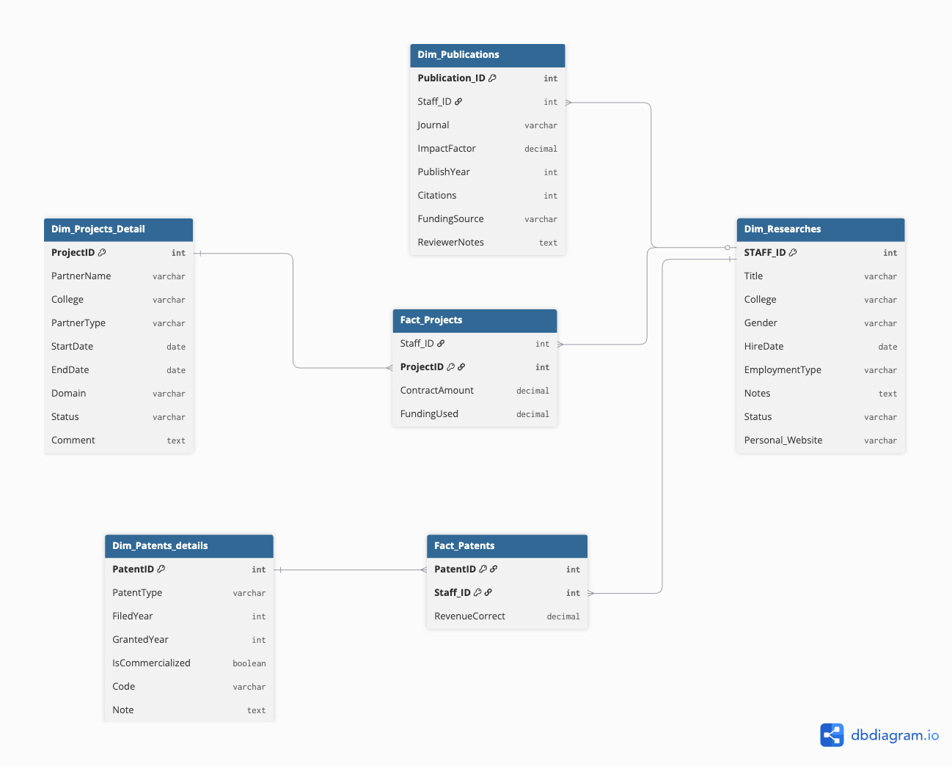

Physical Data Implementation
NOTE: I gave example only with Dim_Projects_Detail table for showcase purpose

Create table queries:
---------------------------------------------------------
-- Create Database and Schema
---------------------------------------------------------
CREATE DATABASE IF NOT EXISTS UniversityDB;

CREATE SCHEMA IF NOT EXISTS UniversityDB.performance_kpis;

USE SCHEMA UniversityDB.performance_kpis;

---------------------------------------------------------
-- Dimension: Research Projects Detail
---------------------------------------------------------
CREATE OR REPLACE TABLE Dim_Projects_Detail (
ProjectID INT PRIMARY KEY,
PartnerName VARCHAR,
College VARCHAR,
PartnerType VARCHAR,
StartDate DATE,
EndDate DATE,
Domain VARCHAR,
Status VARCHAR,
Comment TEXT
);

---------------------------------------------------------
-- Fact: Projects
---------------------------------------------------------
CREATE OR REPLACE TABLE Fact_Projects (
Staff_ID INT,
ProjectID INT,
ContractAmount DECIMAL(18,2),
FundingUsed DECIMAL(18,2),

-- PK
CONSTRAINT pk_fact_projects PRIMARY KEY (ProjectID),

-- FKs
CONSTRAINT fk_factprojects_staff
FOREIGN KEY (Staff_ID) REFERENCES Dim_Researches(STAFF_ID),

CONSTRAINT fk_factprojects_project
FOREIGN KEY (ProjectID) REFERENCES Dim_Projects_Detail(ProjectID)
);

Populate Table queries:
INSERT INTO UniversityDB.performance_kpis.DIM_PROJECTS_DETAIL
(
ProjectID,
PartnerName,
College,
PartnerType,
StartDate,
EndDate,
Domain,
Status,
Comment
)
SELECT
ProjectID,
PartnerName,
College,
PartnerType,
StartDate,
EndDate,
Domain,
Status,
Comment
FROM UNIVERSITY_DATA1.PUBLIC.DIM_PROJECTS_DETAIL;

Dashboard Details (Charts and Kpi-s)
KPI Summary Tiles (Top Section)
- Total Projects: Displays the total number of projects, with a percentage showing how many have been completed.
- Total Patents: Shows the total number of patents along with the commercialization percentage.
- Total Revenue: Indicates the total revenue generated from commercialized patents.
- Total Publications: Shows the total number of publications and how many unique authors contributed.
Filters:
Date Filters (Date From / Date To)
Domain Filter
Status Filter

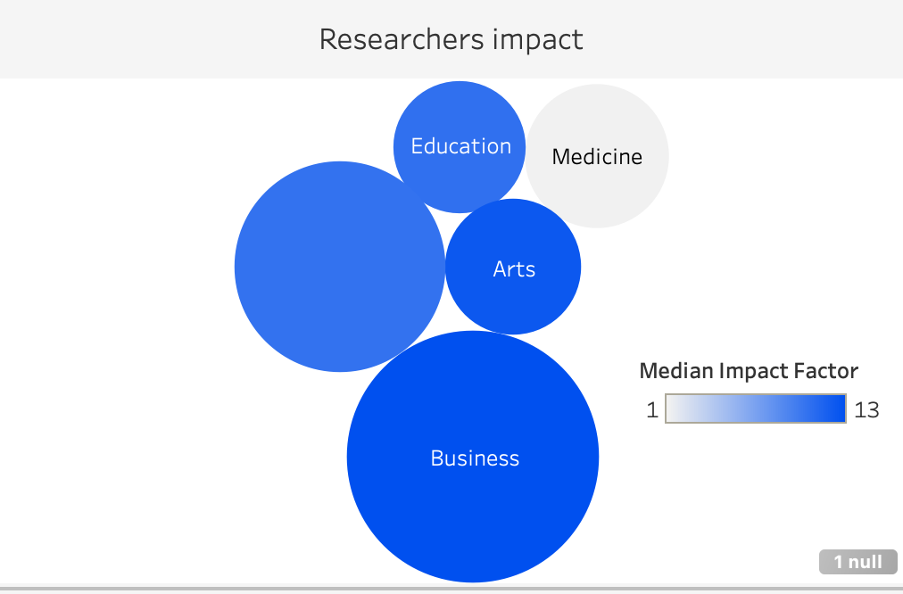
Visual Card | Description | Calculation
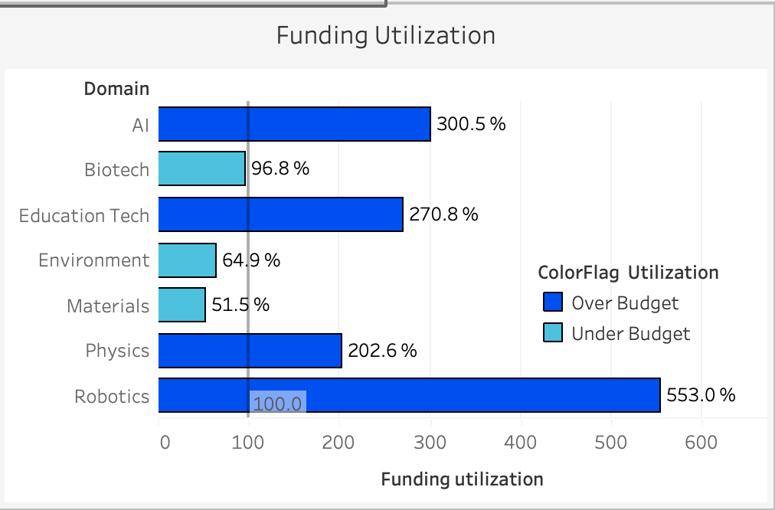 | This bar chart compares Funding Used vs Contract Amount across different research domains in % | sum([Funding Used])/SUM([Contract Amount]) * 100
 | This bubble chart visualizes publication impact by academic domain.  - Bubble size indicates the number of publications per domain.  - Bubble color intensity represents the median impact factor for that domain. | SUM(Citations), Median(Impact)
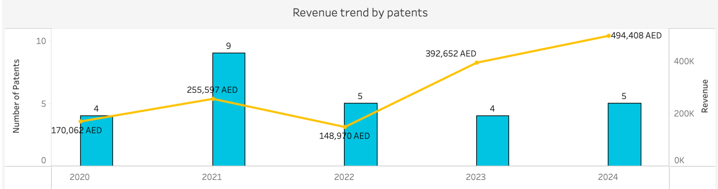 | A combined bar and line chart showing patent performance over time:  - Bars represent the number of patents granted each year.  - Line represents total patent revenue by year.  - Revenue labels display the exact AED amount for each year. | COUNT([Dim_Patents]),SUM([Revenue])

Deliverables
- Business Requirement Document
- Documentation of logical, and physical data models
- SQL scripts for physical implementation
- Tableau dashboard visualizations showcasing insights from the data:

Tableau Dashboard:
https://public.tableau.com/views/Book1_17637174127230/ResearchPerformance?:language=en-US&publish=yes&:sid=&:redirect=auth&:display_count=n&:origin=viz_share_link

